|  |  |  |  |
| --- | --- | --- | --- |
|  | | | |
| **Expt. No:** | | **7** | **Diode Clipper Circuits (Shunt – Configuration)** |
|  | | |
| **Date:** | **24/09/2020** | |
|  | | | |

**Aim:**  To study, design and plot the various shunt diode clipper circuits.

**SOFTWARE TOOLS / OTHER REQUIREMENTS:**

1. Multisim Simulator/Circuit Simulator

# Theory:

We know that when a diode is forward biased it allows current to pass through itself clamping the voltage across it to 0.7 volts (Practical Silicon Diode). While, when it is reverse biased, no current flows through it and the voltage across its terminals is unaffected, and this is the basic operation of the diode clipping circuit.

***Clippers are networks that employ diodes to “clip” away a portion of an input signal without distorting the remaining part of the applied waveform.***

There are two general categories of clippers: ***Series***and ***Parallel****.* The series configuration is defined as the one where the diode is in series with the load, whereas the parallel variety has the diode in a branch parallel to the load.

**shunt configruations**

**shunt positive clipper**

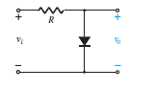

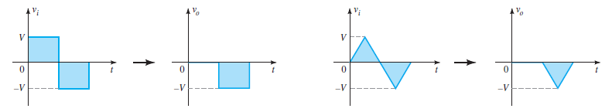

As shown above, when the positive half cycle appears, the diode being forward biased, acts as short circuit and thus the output voltage remains at zero level. During the negative half cycle, the diode is reverse biased, acts as open circuit and hence we see that the output node comes into direct contact with the input node, thereby the output follows the input. Since the positive cycle of the input is getting clipped-off, the configuration in the above circuit is known as shunt positive clipper.

Likewiseif the polarity of the diode is reversed; we can clipp-off the negative half of the input cycle. In this case, during the positive half cycle, the diode remains reverse biased thereby connecting the output node with input node and the output voltage follows the input. But when the negative half cycle appears, the diode gets forward biased creating a short across the output nodes resulting into a zero voltage at the output. The level will be 0.7 if a silicon diode is considered instead of an non-ideal diode.

**few shunt diode clipper configurations**

**positive**

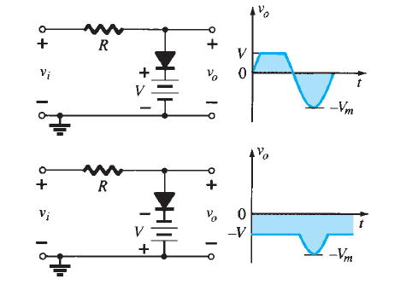

**negative**

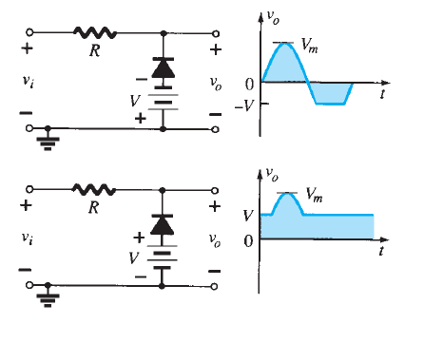

**two level clippers**

These circuits employ clipping in both the directions (Postivie as well as Negative Half Cycles) as shown in figure below:

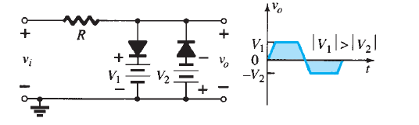

**1.) SHUNT POSITIVE CLipper**

**Circuit/connection diagrams (fROM multisim)**

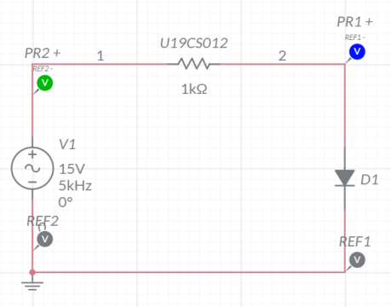

**waveforms (fROM multisim)**

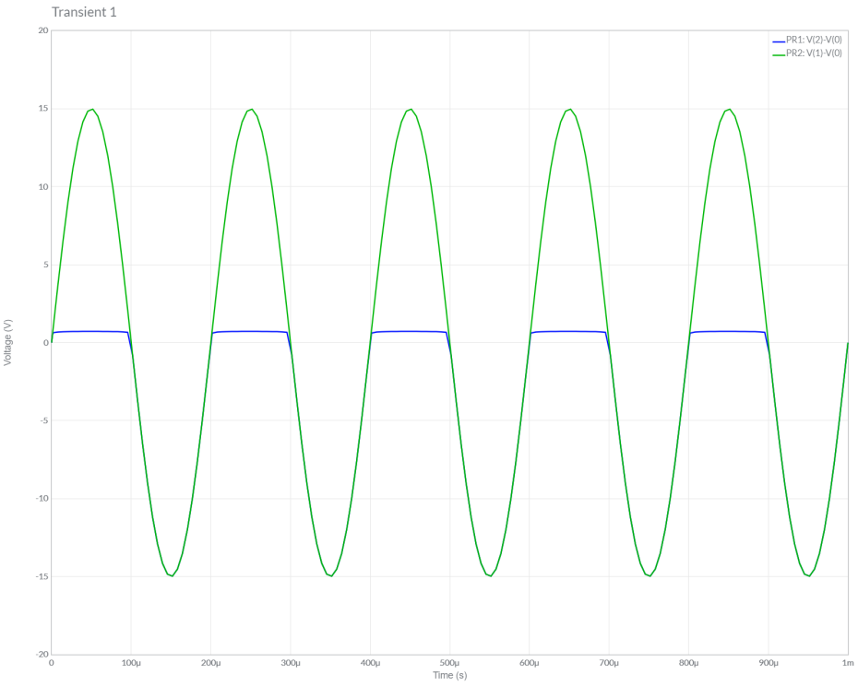

**2.) SHUNT NEGATIVE CLipper**

**Circuit/connection diagrams (fROM multisim)**

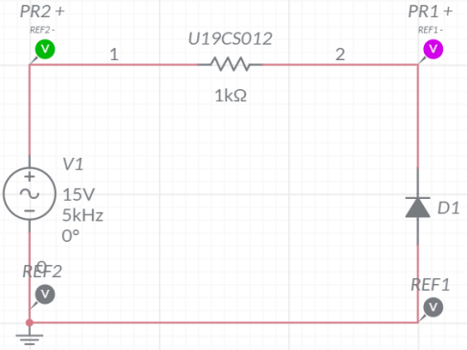

**waveforms (fROM multisim)**

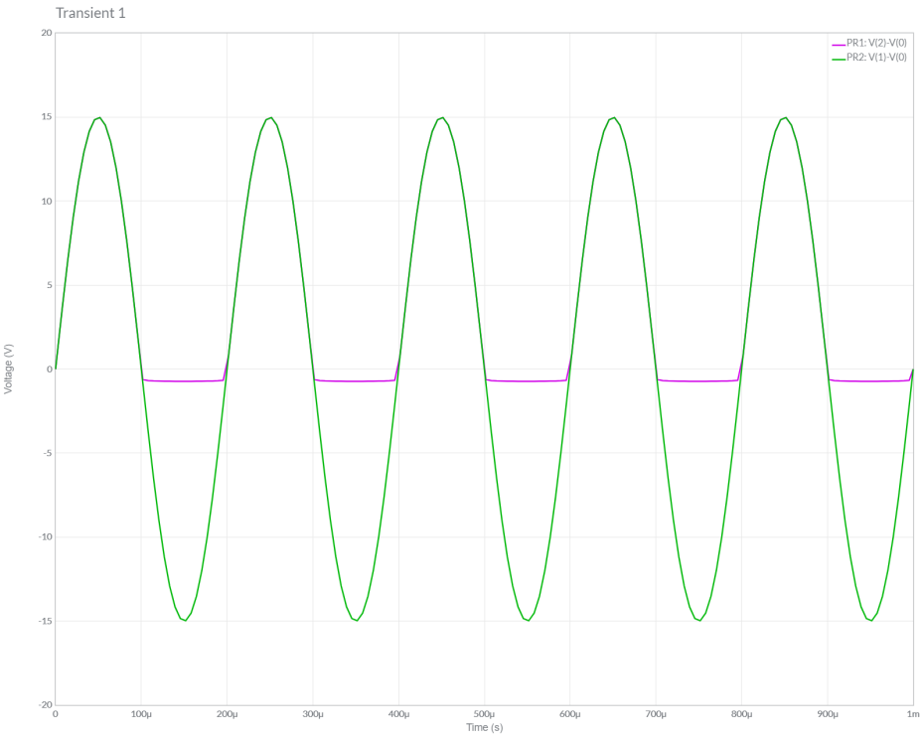

**3.) SHUNT POSITIVE CLipper WITH BIAS-I**

**Circuit/connection diagrams (fROM multisim)**

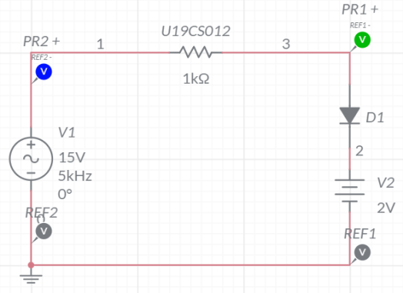

**waveforms (fROM multisim)**

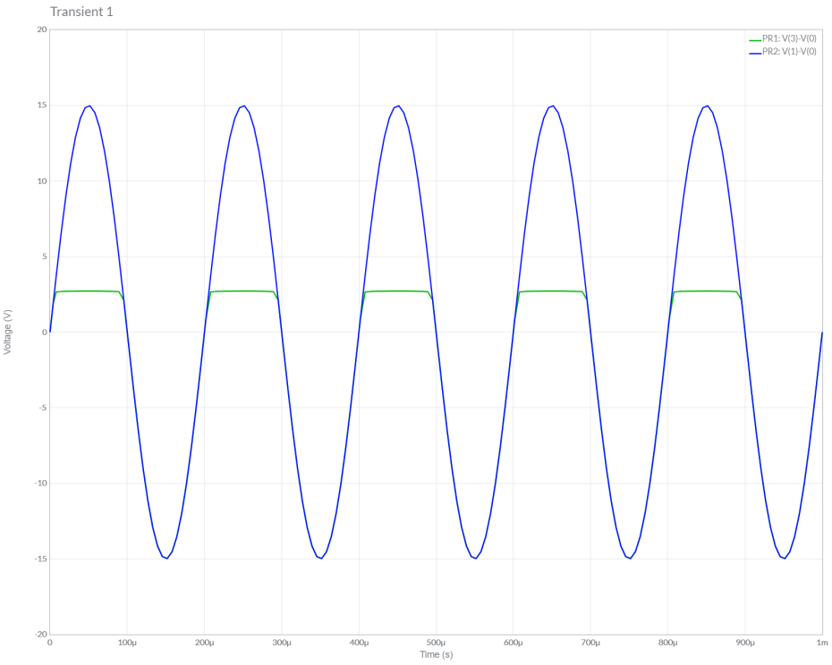

**4.) SHUNT POSITIVE CLipper WITH BIAS-Ii**

**Circuit/connection diagrams (fROM multisim)**

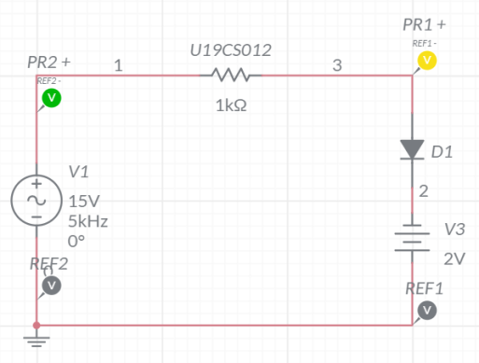

**waveforms (fROM multisim)**

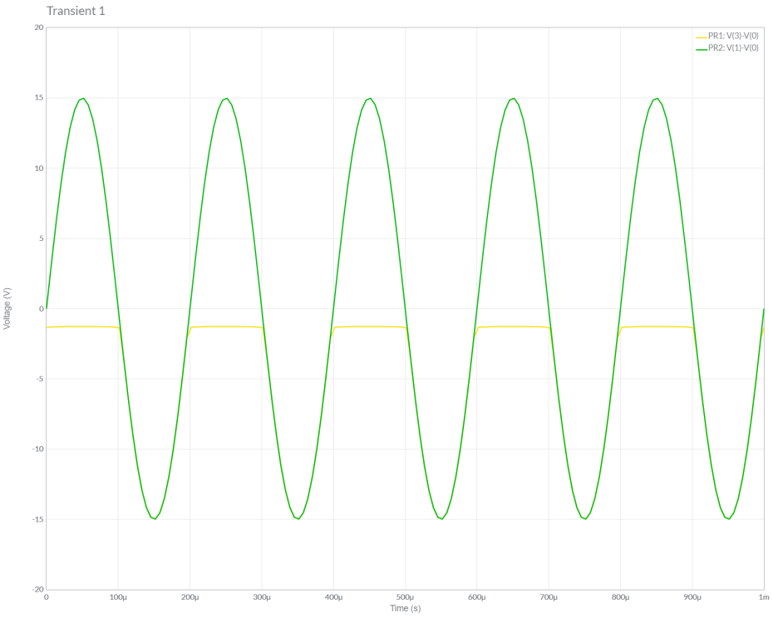

**5.) SHUNT Negative CLipper WITH BIAS-I**

**Circuit/connection diagrams (fROM multisim)**

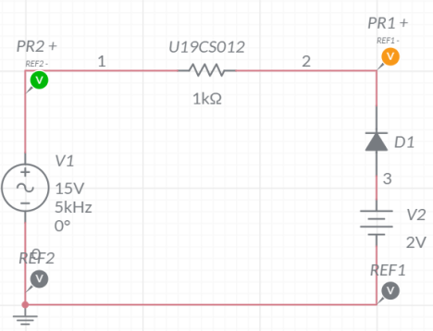

**waveforms (fROM multisim)**

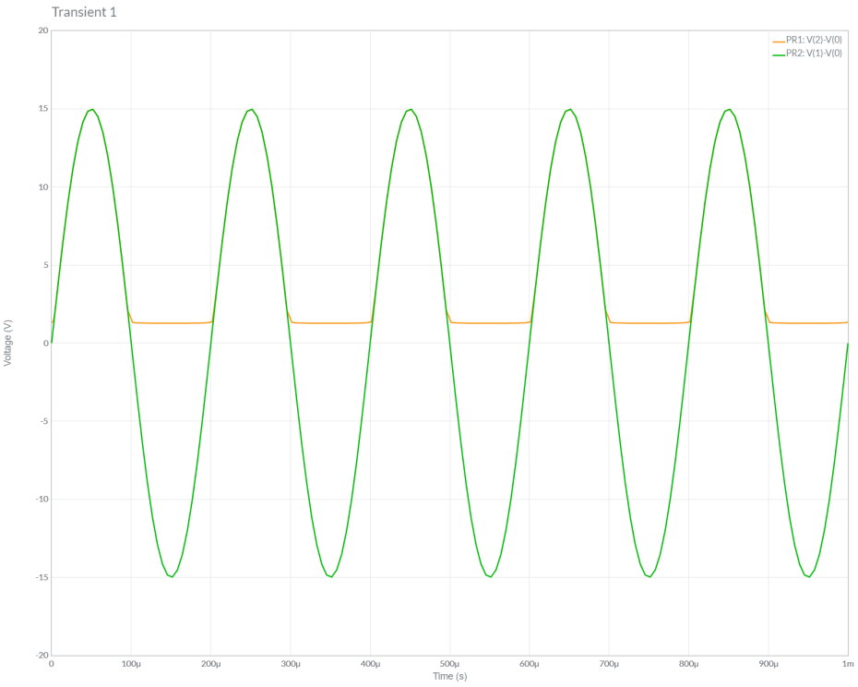

**6.) SHUNT Negative CLipper WITH BIAS-II**

**Circuit/connection diagrams (fROM multisim)**

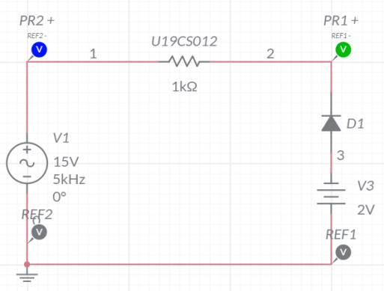

**waveforms (fROM multisim)**

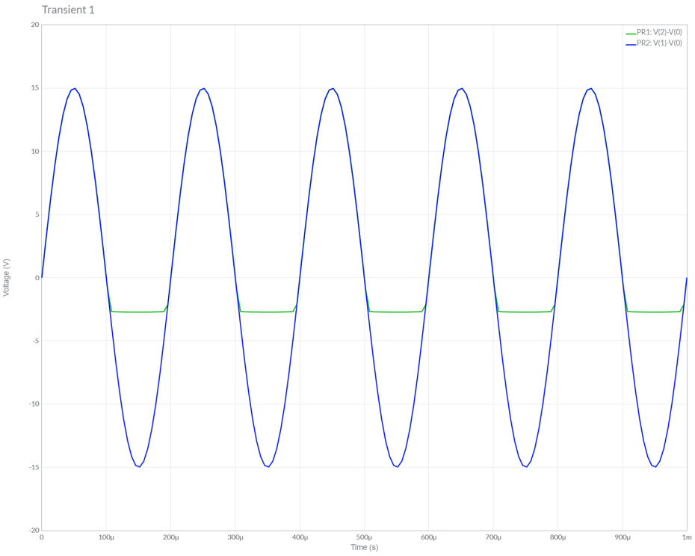

**7.) DUAL CLipper**

**Circuit/connection diagrams (fROM multisim)**

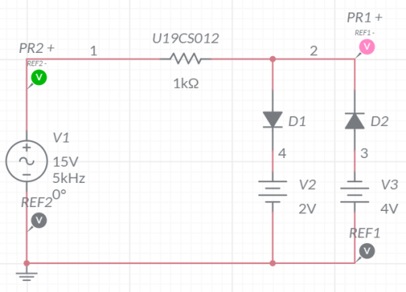

**waveforms (fROM multisim)**

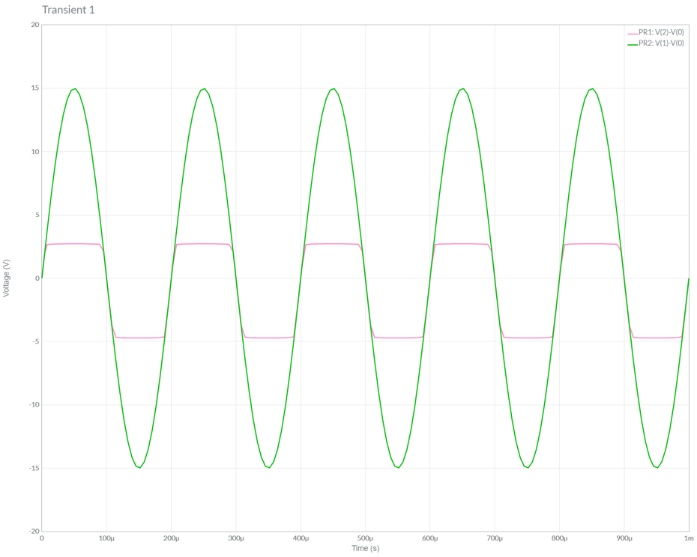

**Conclusions**

1.) In this Experiment, We have studied about Shunt Clipper Circuits [Both Positive and Negative] along with Different Biasing Applied.

2.) We Verified the Theoretical Knowledge of Shunt Clippers by Performing Simulations of 7 Cases of Shunt Clippers in Multisim.

3.) Hence, we have Successfully Designed, Plotted and Verified Various Shunt Diode Clipper Circuits.

**ASSIGNMENT-7**

U19CS012

**1.** Determine and plot the output voltage waveform for the given circuits. Also verify the same using Multisim.

Circuit a.)

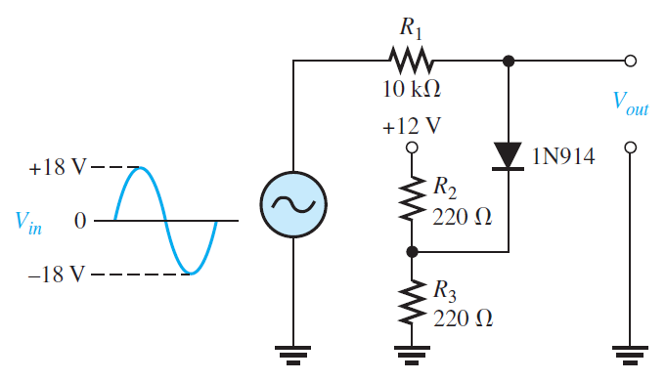

A.) Multisim Calculations:

*1.) Circuit Image:*

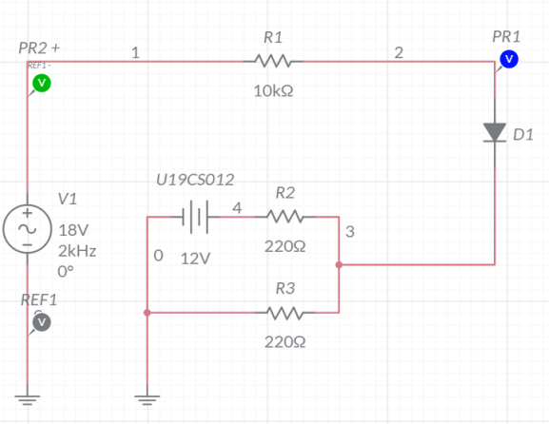

*2.) Grapher Image:*

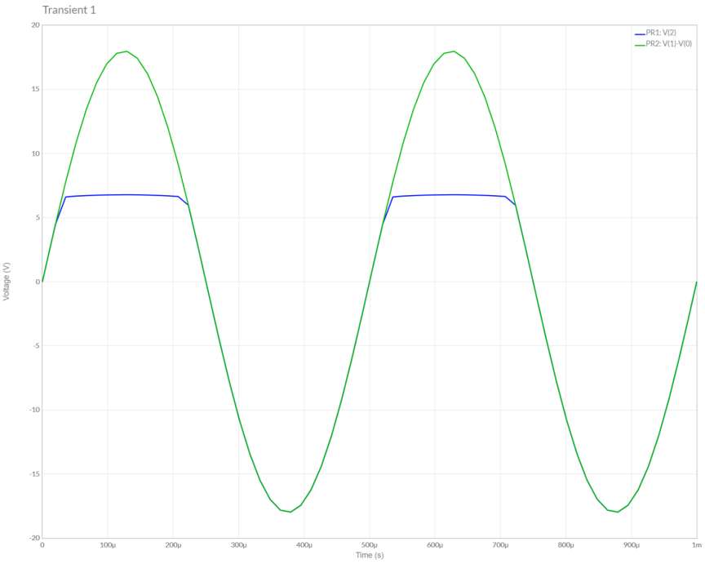

B.) Theoretical Calculations:

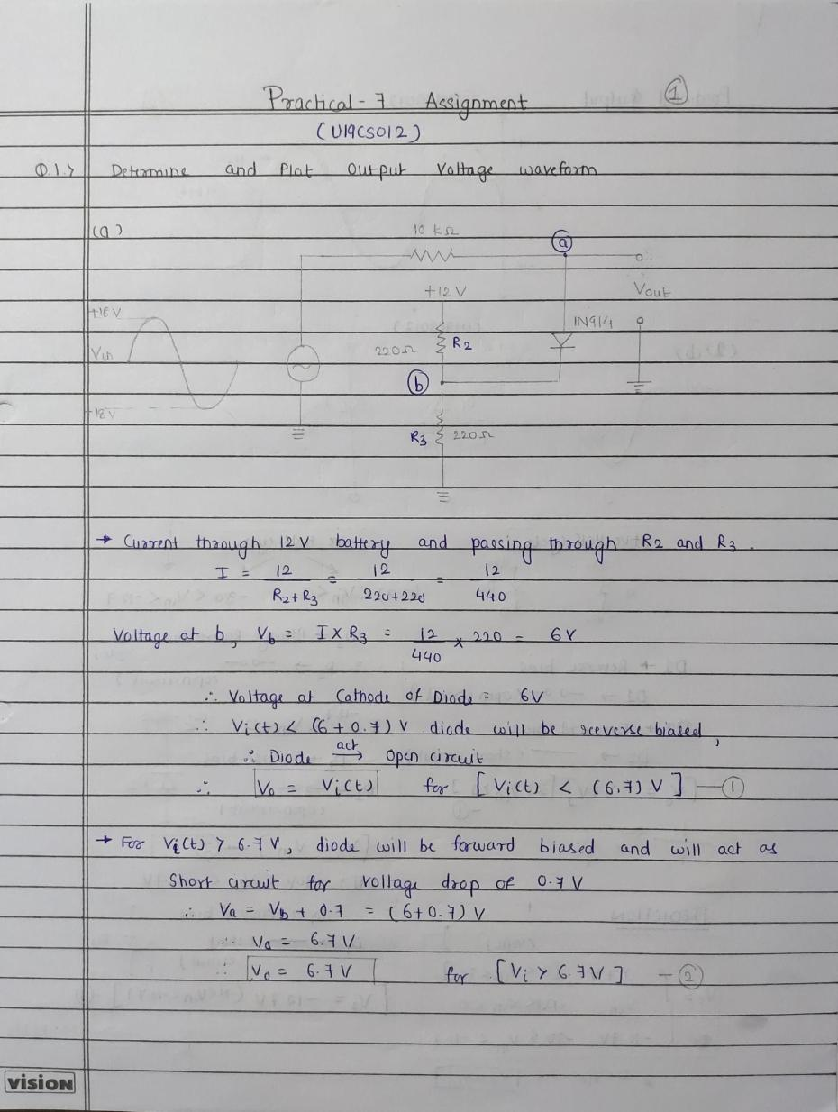

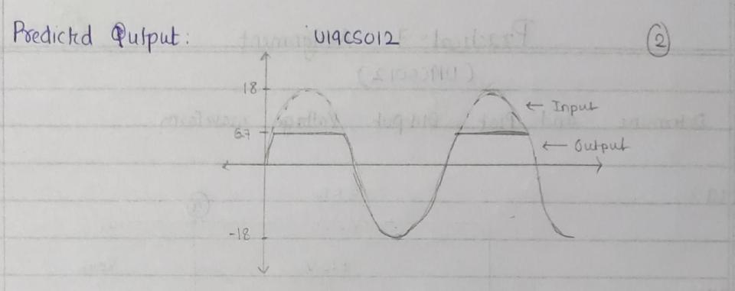

Circuit b.)

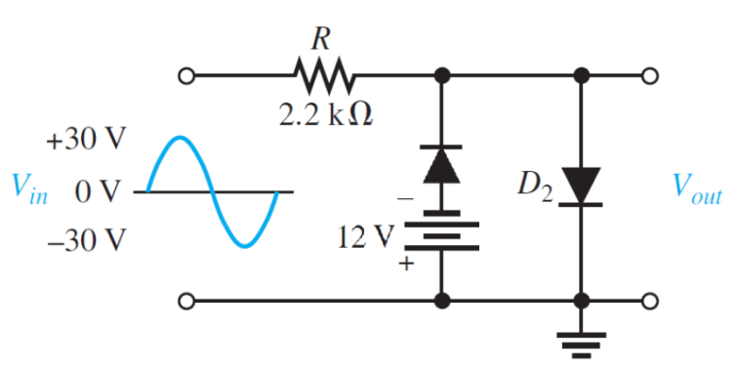

A.) Multisim Calculations:

*1.) Circuit Image:*

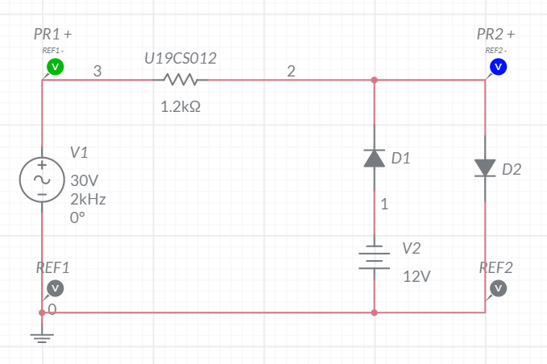

*2.) Grapher Image:*

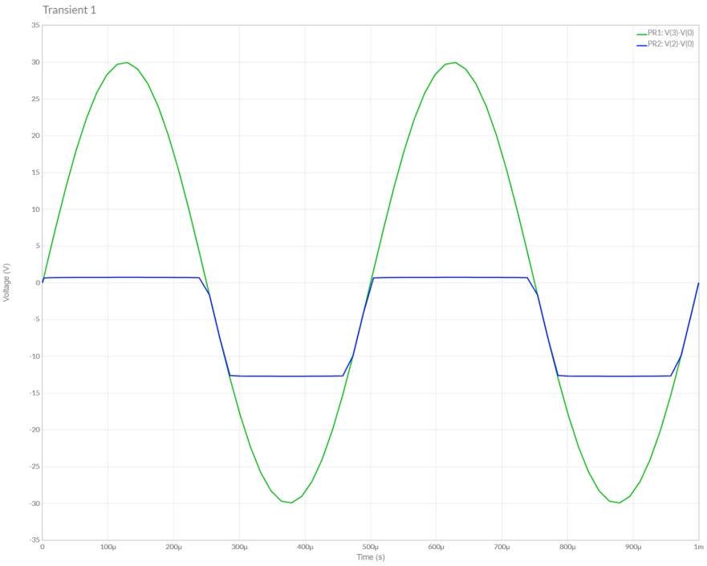

B.) Theoretical Calculations:

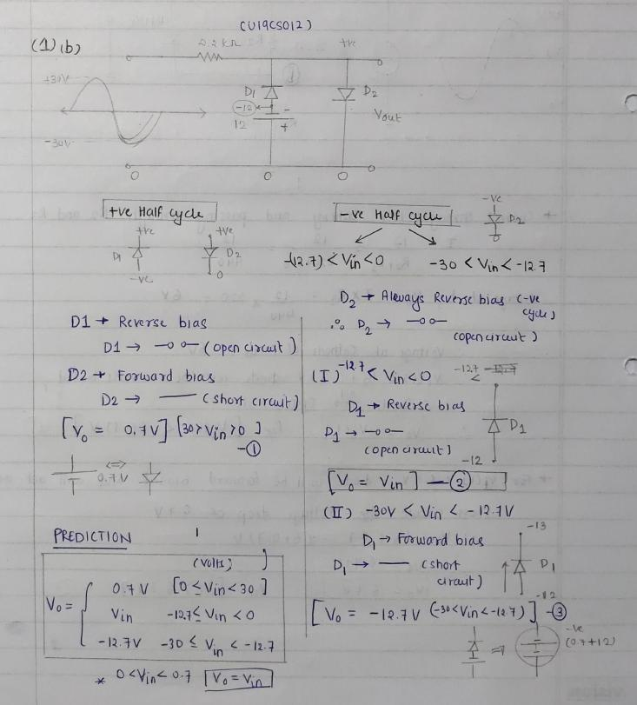

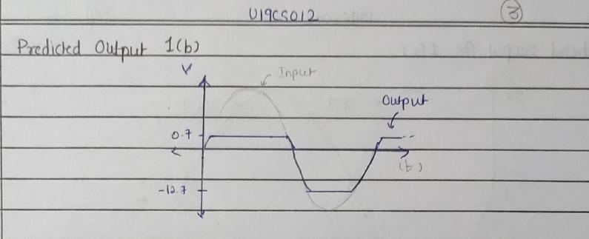

Circuit c.)

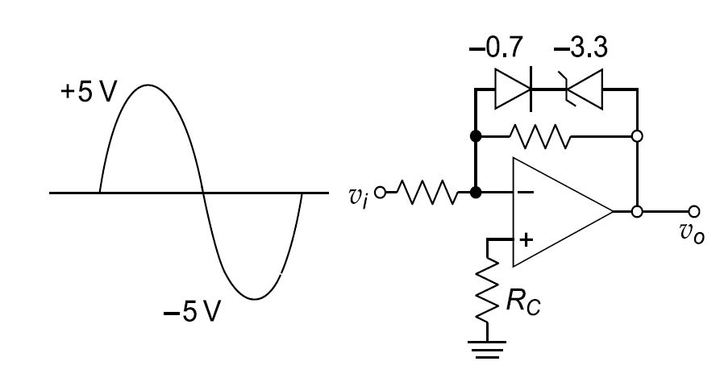

A.) Multisim Calculations:

*1.) Circuit Image:*

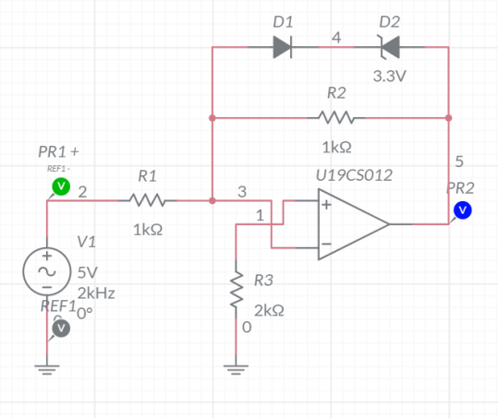

*2.) Grapher Image:*

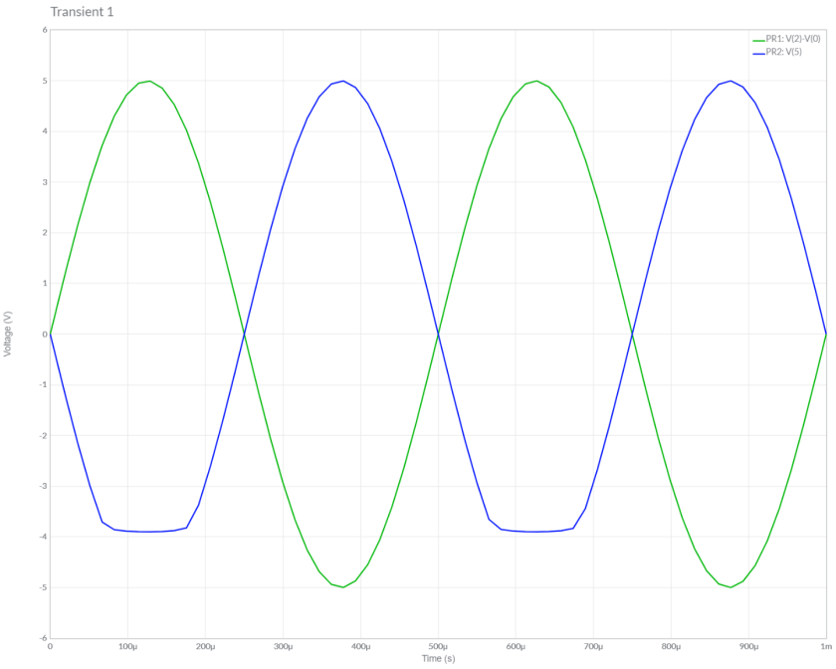

B.) Theoretical Calculations:

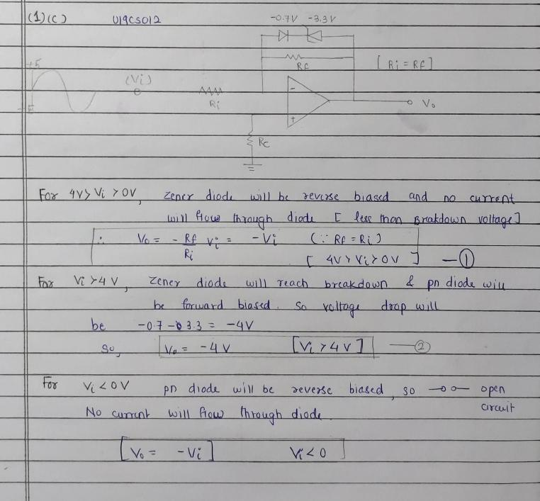

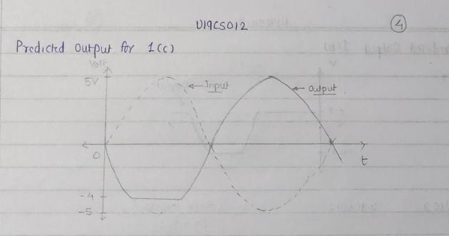

**2.** Draw the transfer characteristics for all the clipper configurations which are part of your today’s practical (Practical – 7).

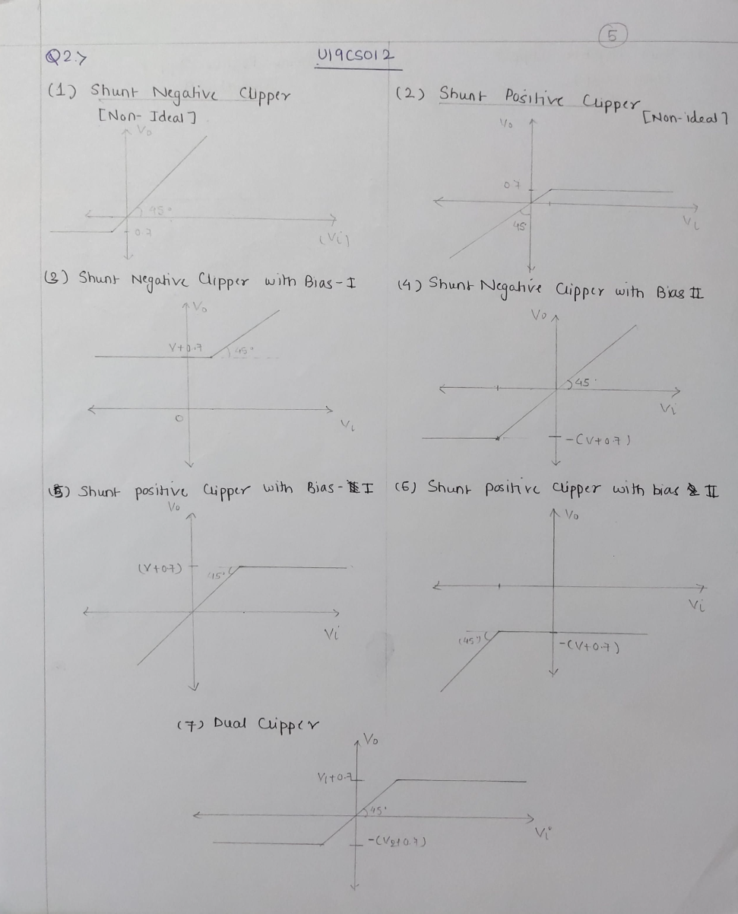

**3.** Assuming Symmetrical Sine wave input with peak value greater than the Zener reference voltage, predict the output and plot the Transfer Characteristics for the following Clipper Circuits:

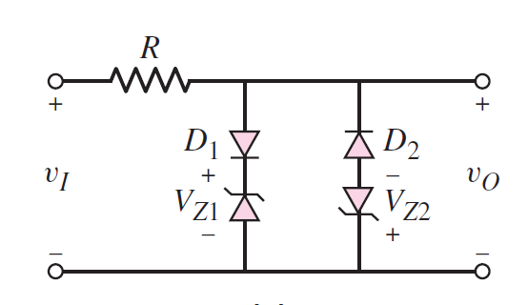

A.) Multisim Calculations:

*1.) Circuit Image:*

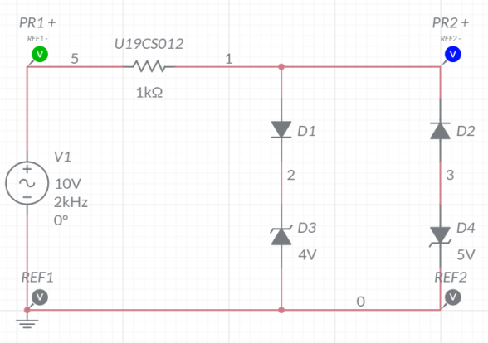

*2.) Grapher Image:*

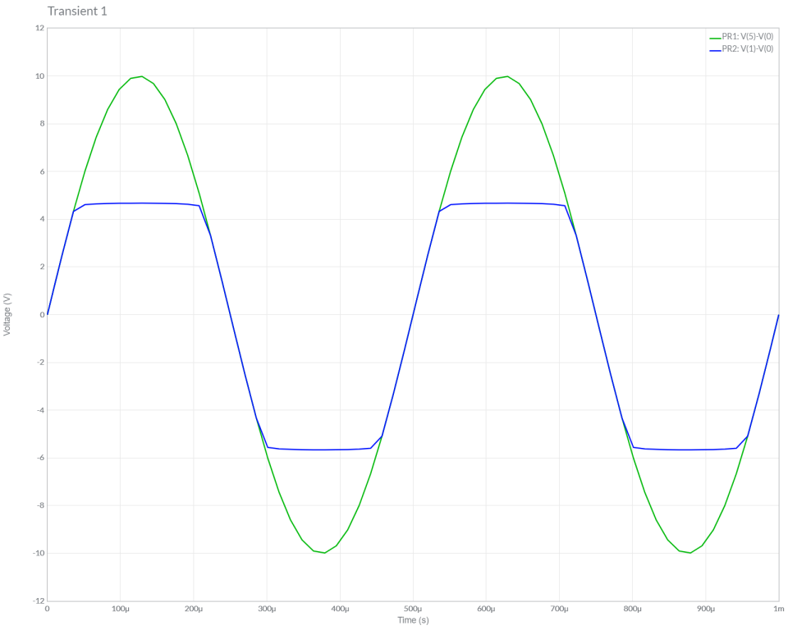

B.) Theoretical Calculations:

